

**Discovery Analytics Tool**

**A user guide by GDDT**

**Version 2.0 (October 2019)**



DISCLAIMER

2019 GDDT. All rights reserved.

This training manual is intended for informational purpose only. The information contained in this manual has been obtained directly from Primavera backend databases and the direct calculations and measurements by GDDT. Every care has been taken by the members of GDDT in compilation of the data contained herein and in verification of its accuracy when published, however the content of this training manual is subject to change without notice due to factors outside the control of GDDT and this manual should, therefore, be used as a guide only.

GDDT does not accept any responsibility for misrepresentation by any person of the information contained in this training manual and expressly disclaims all and any liability and responsibility to any person, whether a reader of this training manual or not, in respect of claims, losses or damage or any other matter, either direct or consequential arising out of or in relation to the use and reliance, whether wholly or partially, upon any information contained or products referred to in this manual.

Glossary

The following terms are used throughout the manual to indicate various levels of emphasis when understanding the reports.

 IMPORTANT: Important tips

 HOW TO READ: This explains how to interpret the information

Contents

**Introduction 5**

**Getting Started 5**

**Logging In 5**

**The Interface 6**

**Report Configuration 7**

**Cover Page 8**

**Generating Reports 9**

**Single-Schedule Check 9**

**Multi-Schedule Checks 9**

**Exporting Report 10**

**Single Schedule Reports 11**

**SS-1 Summary Report Merged 11**

**SS-1 Summary Report -1 15**

**SS-1 Summary Report -2 15**

**SS-2 Detailed Valence 15**

**SS-3 Detailed Logic 16**

**SS-4 Detailed Constraint 17**

**Multi Schedule Reports 18**

**MS-3 Activity Compare 18**

**MS-4 Activity / Logic Stats 21**

**MS-5 Venn Diagram 24**

**MS-6 Activity Stats 27**

**MS-7 Float Map 31**

**MS-8 Schedule Consistency 34**

**Automatic Word Export 42**

**Defense Contract Management Agency (DCMA) 42**

**Phase 1 Report 45**

**Contact Us 46**

# Introduction

Welcome to the Discovery Analytics Tool (DAT) OCR user guide. It is a fully functional bespoke application which contains a suite of analytics reports to identify schedule inconsistencies, duration changes, logic changes, lag alterations, float distribution, milestone tracking and much more. It eliminates the need to access Primavera Planning Software by directly interrogating its backend server. This promises an utmost 100% accuracy on the information it retrieves.

SAT is designed specifically for consultants and planners to analyse project schedules at the most efficient speed. Reports are automatically generated within a click of a button. This user guide provides detailed information on how to operate SAT as well as how to read and understand the reports.

# Getting Started

Before we get started, it is important to ensure that all required software has been installed and configured correctly. Please contact [GDDT@DRIVERTRETT.COM](mailto:GDDT@DRIVERTRETT.COM) to schedule an installation appointment.

## Logging In

Once SAT has been installed and configured, the application can be accessed by clicking on the icon on our desktop.

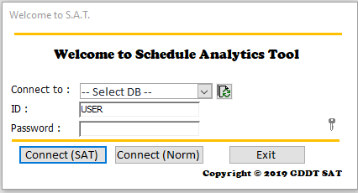When SAT opens, the login screen will be presented. Select the database from the list of dropdowns we wish to connect to, and enter “USER” as the ID, “password” as the password, before clicking on ***Connect (SAT)***.

## The Interface

After logging in, we will be taken to the main interface. 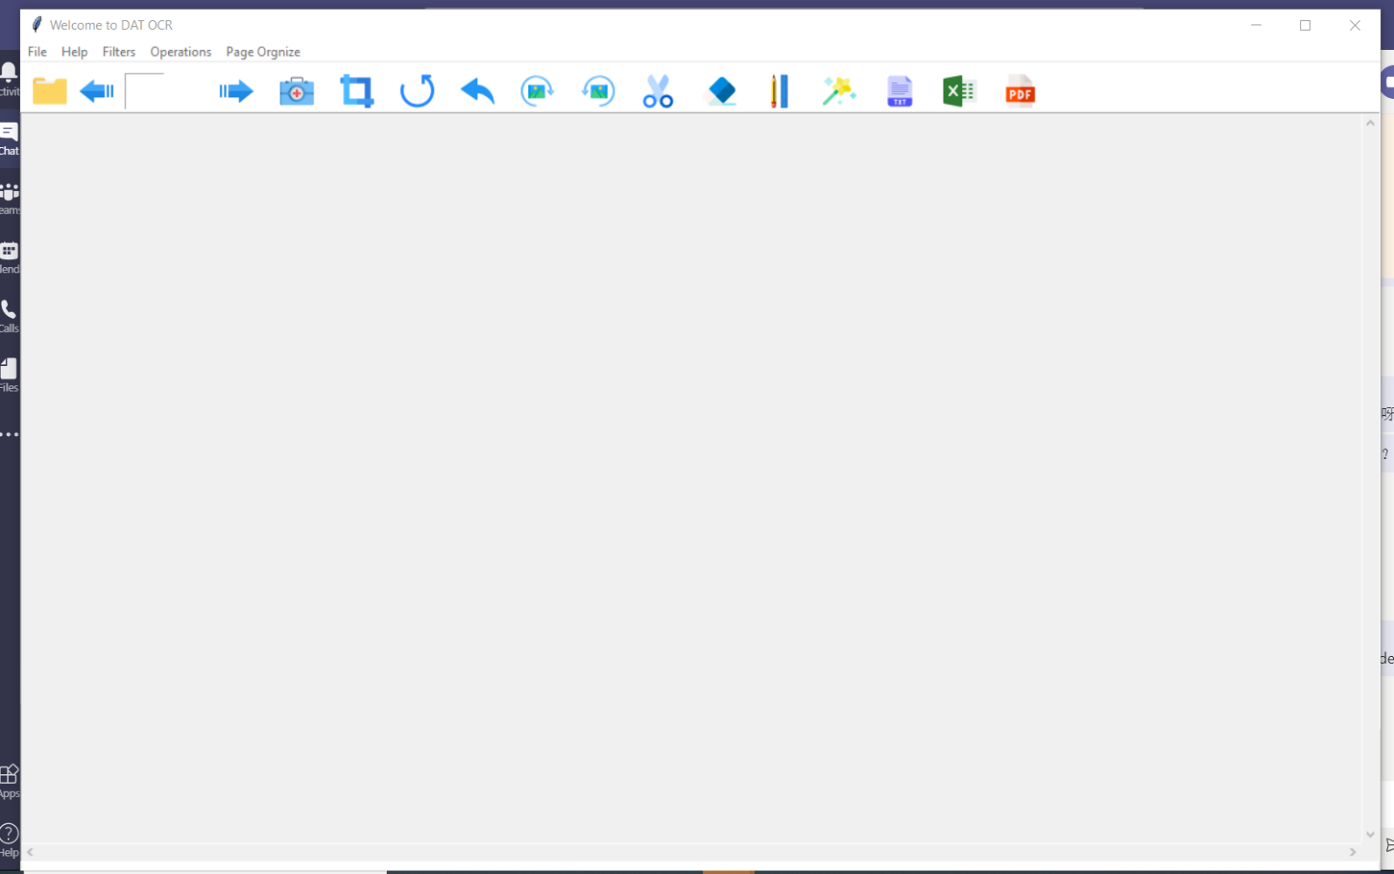

**1**

**2**

**3**

Menu Bar

**1**

Tool Box: Tools for commonly used

**2**

This display the page preview

**3**

# PDF Page Preview

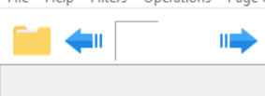Before doing any further extraction, the preview of the pdf can be realized via clicking the button

Then select the specific file from the pop-up window.

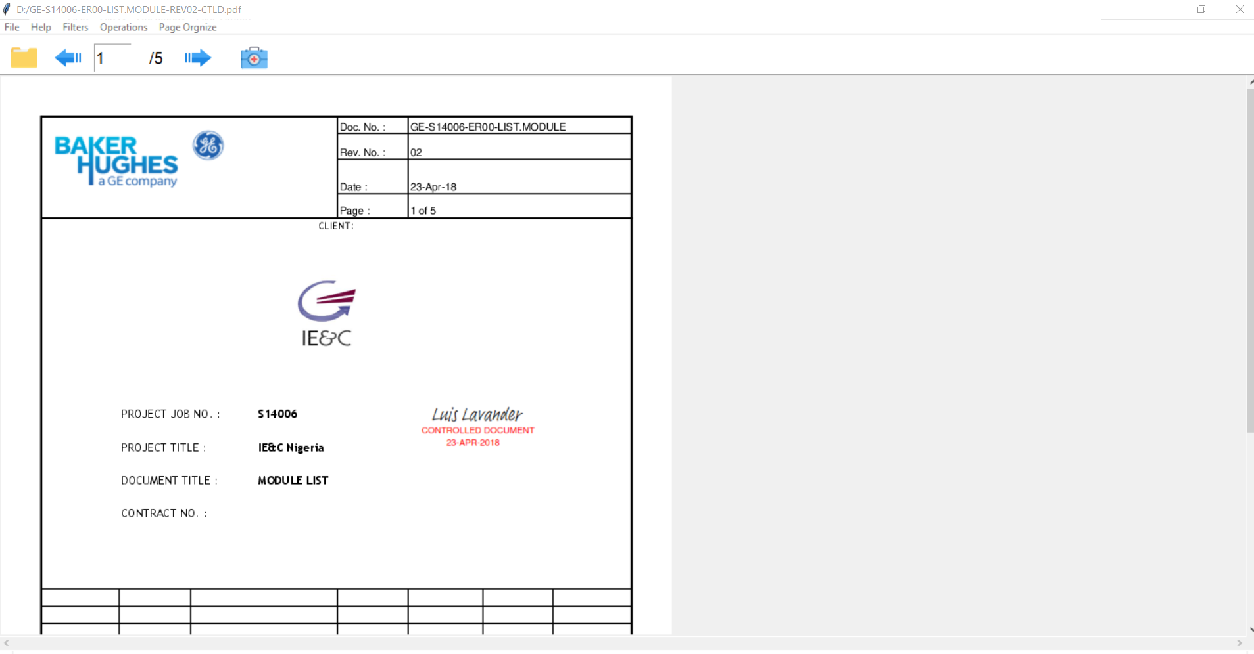

**Name of current previewing file**

**Total page No.**

**Current page No.**

This section allows us to preview the pages and select the page that is needed to be extracted content from. Click the button below to enter into edit mode.

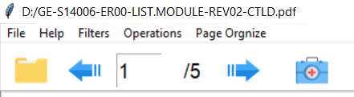

Click the left arrow to flip to previous pages and right arrow to the next page.

# Editing Pages

After entering the edit mode, the user interface will become below.

## 

## Tool Box

this button is to detect the table from scanned page Automatically, and de-skew the image.

 this button is to get back to the raw image.

this button is undo button.

rotate the image clockwise 1°.

rotate the image counter clockwise 1°

scissors, select and drag the area, then cut.

eraser, manual remove those noise.

drawing auxiliary lines

wand, to remove the table border automatically.

export to .txt format files

export to .xlsx files, excel spread sheet.

export to .pdf files, searchable pdf.

## Menu Bar

### Filters

Filters will be affecting the pages with different outcomes. Those effects will make the pages more OCR friendly

* Medium Blur: for those pages which have lots of noise spots
* Gaussian Blur: for the unclear pages
* Erosion: to make the page darker
* Dilation: to make to page lighter

### Operations

### 

Eraser: to remove the noise area by dragging a rectangle

Fine liner: to draw lines for better tabular page extraction. TBF

Corner Pick: TBF

Border Removal: to remove the table border automatically, (if not accurate, can use the Eraser)

### Page Organize

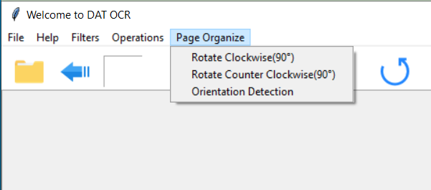

Rotate Clockwise(90°) :

Rotate Counter Clockwise(90°) :

Orientation Detection: 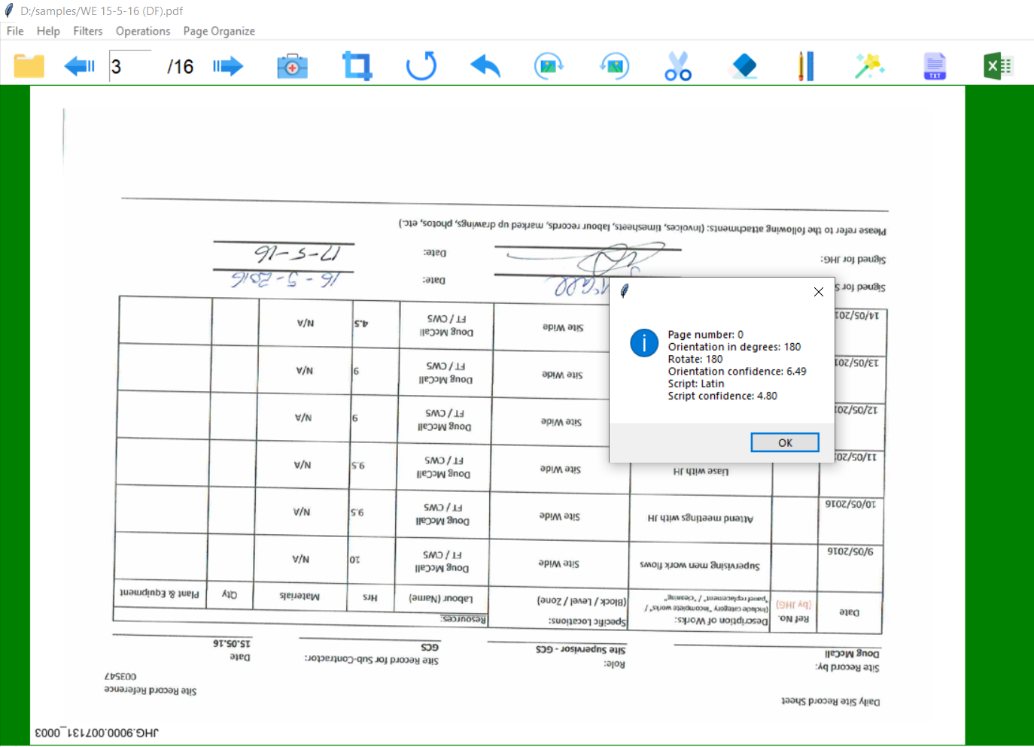

# Page Manipulations

## Exports

DAT-OCR allows multiple formats of exports to satisfy user’s different requirement.

### I. TEXT:

You can extract the content into txt format via clicking , or you can crop the area you need first and then extract the content from there.

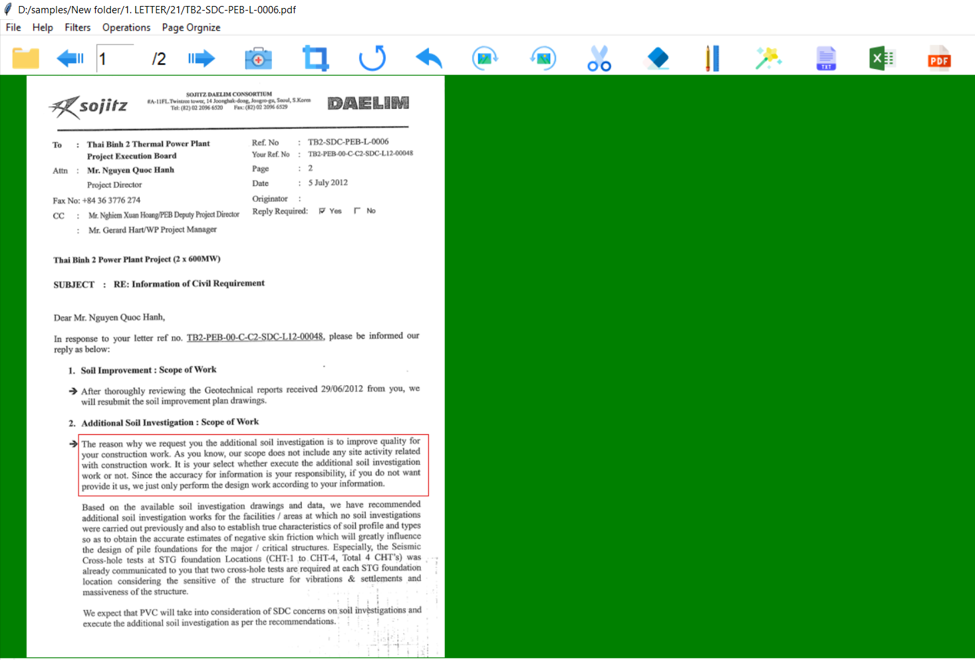

Drag your mouse to the draw a rectangle on the area, then click 

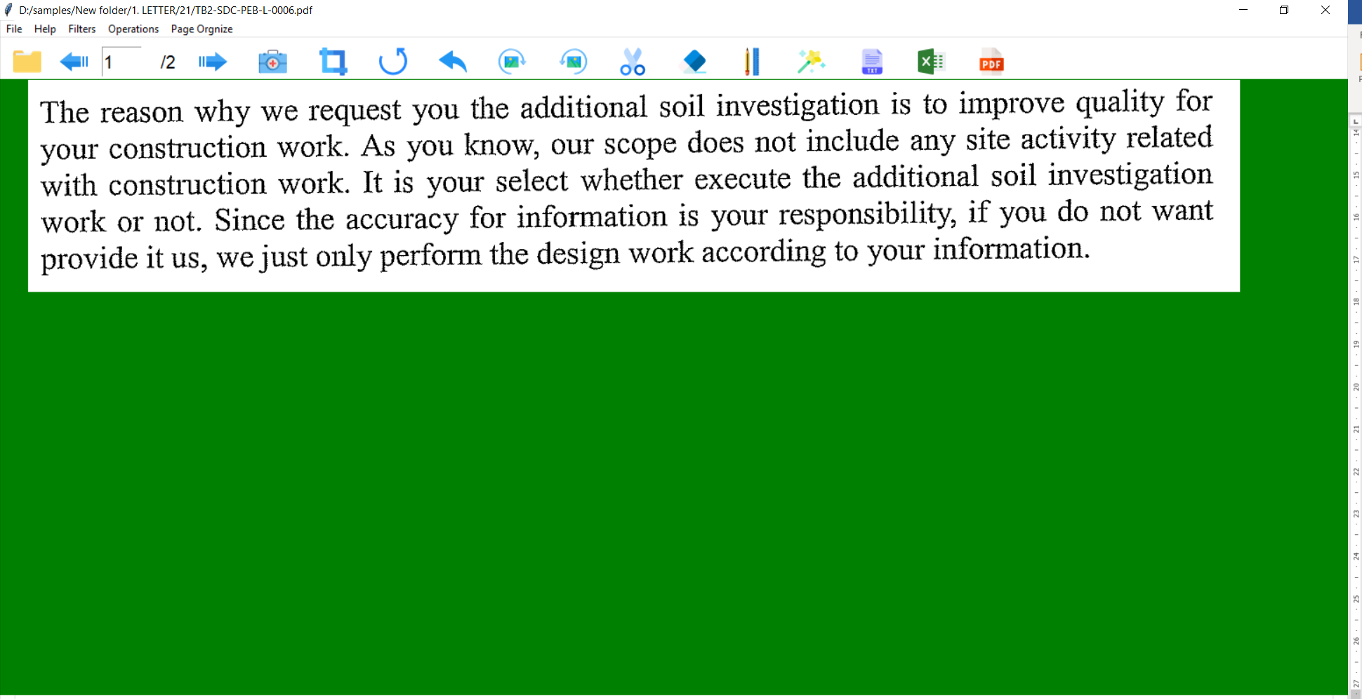

Then click , then a window will pop up

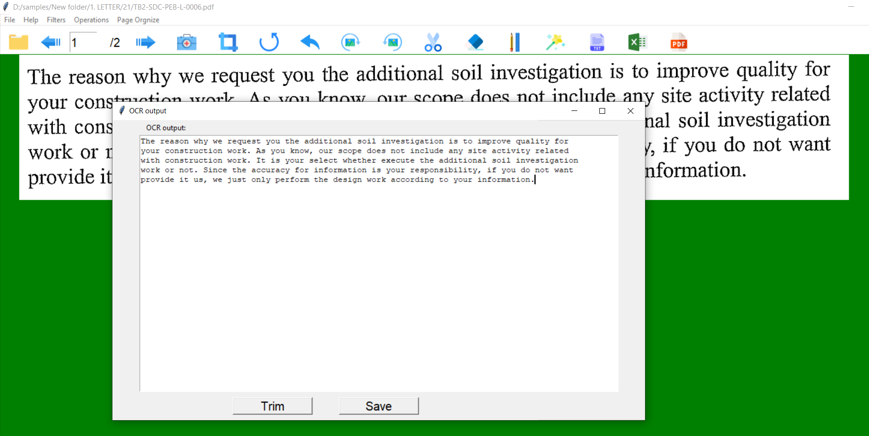

**OCR outputs**

In this pop-up window, you can check the output and do amendments on top of the outcome. See the gif below.



To save the outcome, click the button “save” and give a file name.

For the tabular page, the output might have some trailing newlines, the “Trim” button is to remove them.



### II. EXCEL SPREAD SHEET

For tabular page, user can choose to export as .xlsx file via clicking 

Step1 drag a rectangle that cover the table you want to extract

Step2 click 



### III. Searchable PDFs

Some of the documents which is a scan of a hard copy is not searchable. It is not convenient especially when you want to find out a key word. Thus, you may need to convert them to a searchable PDFs.

Select the specific page that you want to do the converting and click 

Below is the demonstration of the effects **after** converting to searchable pdf.



# Image De-noise

For those scanned documents which are not getting good OCR outputs, you are suggested to do some image pre-processing before OCRing.

Below are some tips for your reference.

## Image de-skew

There are several methods of straightening an image. In most cases, the skewed page is not OCR friendly, thus, may need to be manual de-skewed.

1. Rotate the image via the buttons

Pros: it is more accurate

Cons: need to do it manually and slightly



1. AUTO image transforming 

Pros: sometimes not that accurate

Cons: simple and easy, for tabular page only



## Remove noise

# Contact Us

GDDT@DRIVERTRETT.COM